DATA STRUCTURES AND ALGORITHMS
EXPERIMENT-1
Roll no: 25BAD014
Name: Ashvitha I
Class:A-10 Slot
Course Code: 25CSI024

QUESTION 1:
Squaring a Sorted
Aim:
To write and execute a C program to square each element of a sorted array and display the squared values in sorted order using the Two-Pointer technique.
Pseudocode :
START
Read N
Declare array arr[N] and result[N]
FOR i = 0 to N-1
Read arr[i]
END FOR
left = 0
right = N - 1
index = N - 1
WHILE left <= right
IF |arr[left]| > |arr[right]| THEN
result[index] = arr[left] × arr[left]
left = left + 1
ELSE
result[index] = arr[right] × arr[right]
right = right – 1
END IF
index = index – 1
END WHILE
Print "Sorted squared array"
FOR i = 0 to N-1
Print result[i]
END FOR
STOP
Sourse Code:
https://github.com/ashvitha366/24CSI024-25BAD014/blob/993682807b982994318af6860d38ca0032aaa6b6/Squaring%20a%20sorted%20array(Two-pointer).c

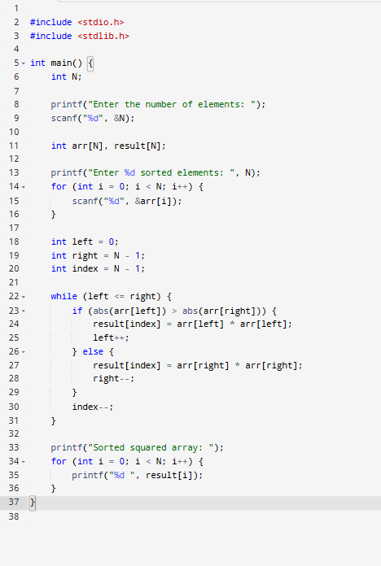
Output:
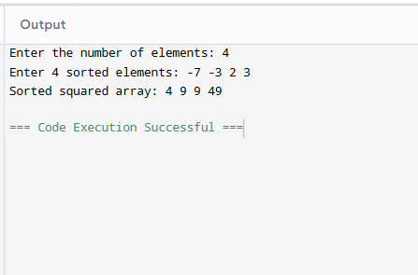

Result:
Thus, the C program to compute the prefix sum of an array and display the prefix sum array was successfully executed, and the desired output was obtained.

QUESTION 2:
Cumulative Resource Consumption

Aim
To write and execute a C program to compute the prefix sum of an array and display the prefix sum array.
Pseudocode
START
Read N
Declare arrays arr[N] and prefix[N]
FOR i = 0 to N-1
Read arr[i]
END FOR
prefix[0] = arr[0]
FOR i = 1 to N-1
prefix[i] = prefix[i-1] + arr[i]
END FOR
Print "Prefix Sum Array"
FOR i = 0 to N-1
Print prefix[i]
END FOR
STOP
Sourse Code:
https://github.com/ashvitha366/24CSI024-25BAD014/blob/93b8980fb3cdffa8961e7bab04bfb6779a0570ee/Cumulative%20Resource%20Consumption.c

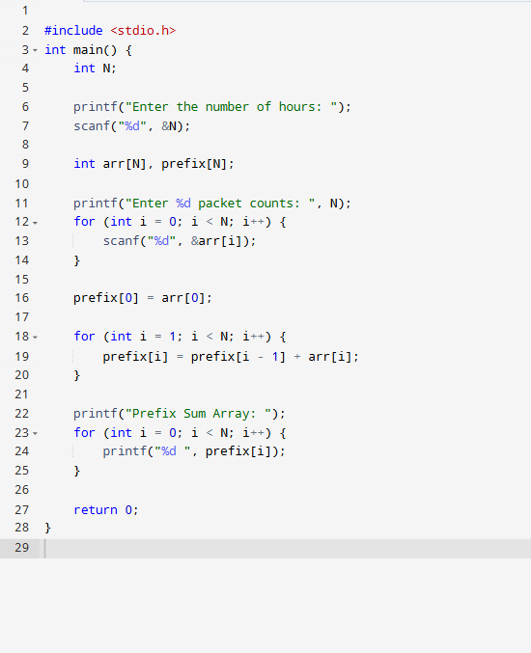
Output:
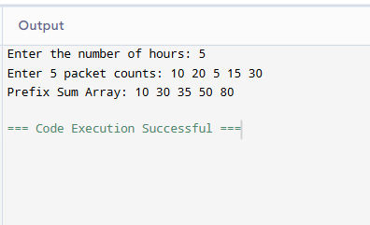

Result:
Thus, the C program to compute the prefix sum of an array was successfully executed, and the prefix sum array was displayed correctly.

QUESTION 3:

Aim:
To write and execute a C program to compute the prefix sum of an array and display the prefix sum array.

Pseudocode:
START
Read N
Declare arrays arr[N] and prefix[N]
FOR i = 0 to N-1
Read arr[i]
END FORprefix[0] = arr[0]
FOR i = 1 to N-1
prefix[i] = prefix[i-1] + arr[i]
END FOR
Print "Prefix Sum Array"
FOR i = 0 to N-1
Print prefix[i]
END FOR
STOP
Source Code:
https://github.com/ashvitha366/24CSI024-25BAD014/blob/d2727ae2f19e406fcf9bf735befa29e0a05a083b/Maximum%20Task%20Window%20Within%20Budget.c

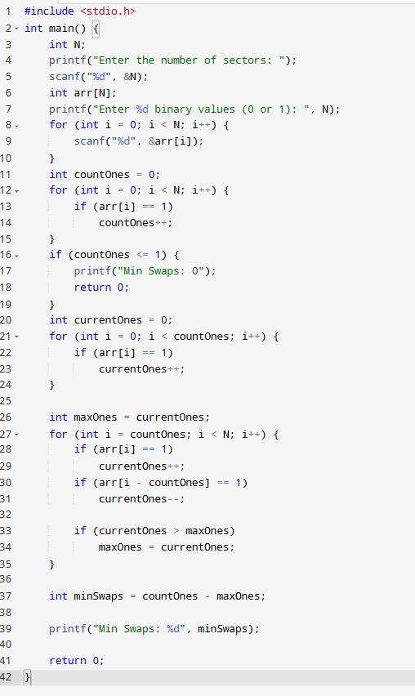

Output:
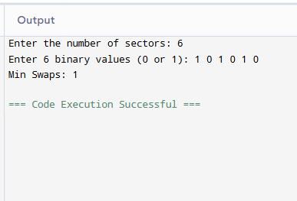
Result:
Thus, the C program to compute the prefix sum of an array was successfully executed, and the prefix sum array was displayed correctly.

QUESTION 4:
Aim:
To write and execute a C program to find the maximum element in every sliding window of size K using the Deque (Double-Ended Queue) technique.

Pseudocode:
START
Read N and K
Declare arrays arr[N] and deque[N]
Read N elements into arr
Set front = 0, rear = -1
FOR i = 0 to N-1
IF deque is not empty AND front element is outside the current window
Remove front element
END IF
WHILE deque is not empty AND
arr[last index in deque] <= arr[i]
Remove last element
END WHILE
Insert current index i at the rear of deque
IF i >= K - 1
Print arr[front index of deque]
END IF
END FOR
STOP
Source Code:
https://github.com/ashvitha366/24CSI024-25BAD014/blob/bf47a8467d9942ad3480dd1ec052a61137506c24/Sliding%20Window%20Maximum%20Peak.c

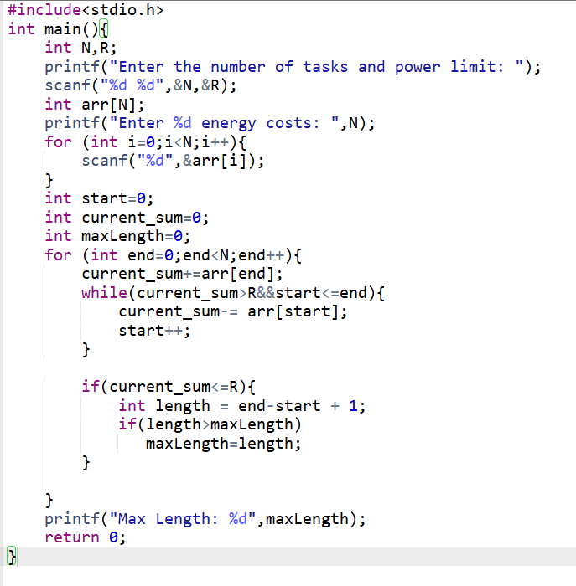

Output:
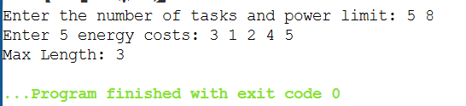

Result:
Thus, the C program to find the maximum element in every sliding window of size K using the Deque (Double-Ended Queue) technique was successfully executed, and the desired output was obtained.

QUESTION 5:

Aim:
To write a C program to find the maximum element in every sliding window of size K using a Monotonic Deque with O(N) time complexity.
Pseudo Code:
START
Read N and K
Declare array arr[N]
Declare deque[N]
Read N array elements
Set front = 0
Set rear = -1
FOR i = 0 TO N - 1
IF front <= rear AND deque[front] <= i - K THEN
front = front + 1
END IF
WHILE front <= rear AND arr[deque[rear]] <= arr[i] DO
rear = rear - 1
END WHILE
rear = rear + 1
deque[rear] = i
IF i >= K - 1 THEN
Print arr[deque[front]]
END IF
END FOR
STOP
Source Code:
https://github.com/ashvitha366/24CSI024-25BAD014/blob/0f1eefd3f55f121c75b068b83091a5fade68ba08/Squaring%20a%20sorted%20array(Two-pointer).c

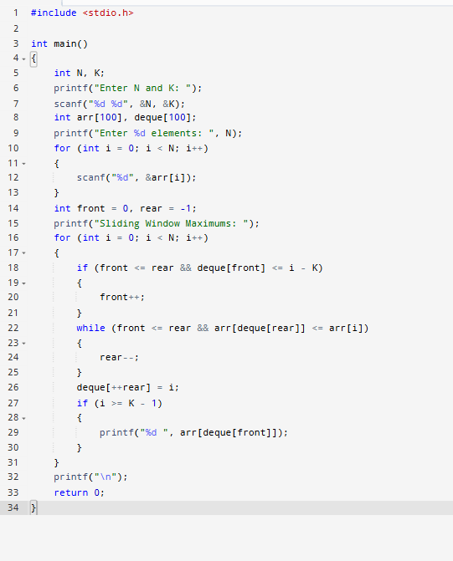

OUTPUT:
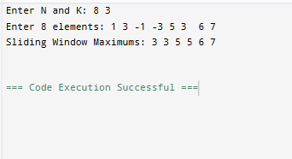

RESULT:
Thus, the C program to find the maximum element in every sliding window of size K using a Monotonic Deque was implemented and executed successfully

